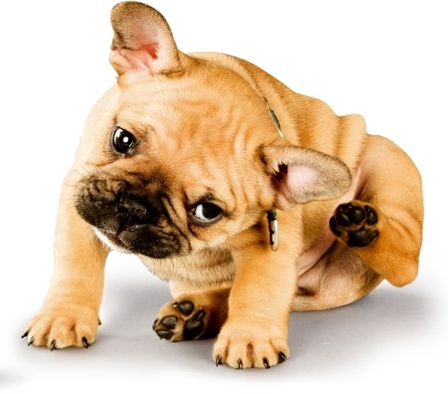
Why does my pet scratch?

Is your dog or cat always scratching and itching? Skin problems are some of the most commonly reported medical complaints about both dogs and cats. The first warning signs are usually something like when you see your cat biting its coat or your dog scratching his ears, licking the feet between toes or scooting their rear end on the ground for prolonged periods of time.
It might be because of fleas. It could be that your pet suffers allergies. It is quite likely that your pet has an allergy if he or she is constantly scratching, licking, rubbing or chewing their skin excessively to the point where there is hair loss or the skin becomes bald, red and painful. This type of skin problem is called atopic dermatitis, an allergic skin condition akin to eczema.
While many of us suffer from hay fever in spring and summer, pets too can be allergic to the same grasses, trees, plant pollen, dust mites and moulds as well as certain foods. Up to 1 in 5 dogs suffer skin allergies and 10% of dogs suffer from atopic dermatitis. The main signs of atopic dermatitis can involve red, itchy skin, obsessive grooming,hair loss and even ear infections. Atopic dermatitis is generally seasonal but it can sometimes be more severe in some dogs and affect them all year long. Because there are many health problems that can first present themselves as itchy skin, it’s a good idea to head to your local vet first to identify the cause and the best methods to treat the problem.

Flea season is fast approaching and not only are they a nuisance, they can also cause extreme itchiness, allergies and skin infections, and can transmit diseases to our pets too. Warm weather and humid indoor environments are perfect for fleas to breed and grow, and it can often be frustrating when your cat or dog repeatedly gets heavy flea infestations.
What you can do at home;
Be absolutely vigilant with flea treatment all year round and use a good quality product and thoroughly clean and vacuum your pet’s environment, including bedding and carpet.
Visit Mt Evelyn Vet to talk to one of our team about many of the great products to help with the itches, including Essential 6, Omega fatty acids, flea treatments, prescription food for cases of food allergies. We also have a variety of specialised shampoos and conditioning lotions which are inexpensive, easy to use and will provide much needed relief for your pooch.
Keep your pet away from known ‘problem’ plants – including Wandering Jew, Paspalum grasses and any type of ivy.
