Treats baked at home for your dog

A quick google search for home made recipes for dogs brings up endless recipes, good, bad and otherwise. I decided to give one recipe a try in the lead up to Christmas, using my own pets and a couple of friends as guinea pig taste testers. I recruited the “help” of my two year old as well.

Here’s the recipe I found for Pumpkin and peanut butter dog treats:
- 2 ½ cups of brown rice flour (I could only find white, maybe I didn’t look hard enough!)
- ½ cup of pureed pumpkin
- ¼ cup of natural creamy peanut butter- ensure this has no sugar or xylitol added
- 2 large eggs

Method:
- Pre heat the over to 180 degrees celsius
- In a large bowl, whisk the eggs, pumpkin and peanut butter until smooth. Add the flour and mix with a rubber spatula or your hands to form a stiff, dry dough (if the dough is too dry to hold together, add a few drops of water, or a little more pumpkin, as needed)
- Dust your counter or work surface with a little flour. Roll the dough to between ¼ to ½ inch thick. Cut into your desired shapes. I found the dough to be quite crumbly but was still able to cut out shapes without them falling apart.

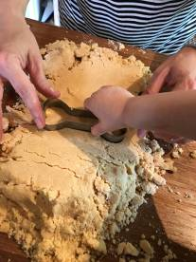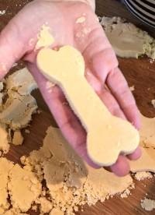

- Place the biscuits onto a lined baking tray (spacing close together is fine as they won’t rise) and bake for 20 minutes. Remove the tray and turn over each biscuit and bake for a further 10-20 minutes or until completely cool.

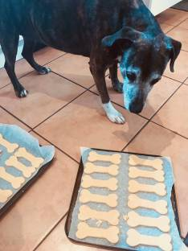

Now the moment of truth:
Matilda the dog-
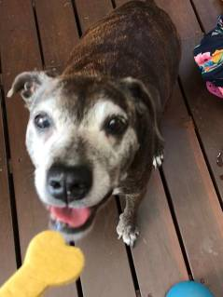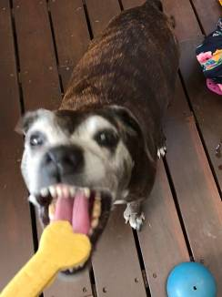

Success!! But maybe she’s not the most picky of taste testers given the only thing she won’t try is lettuce. Ok, lets go to extreme difficulty level and try Millie the cat:
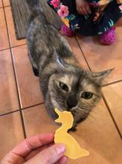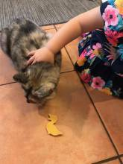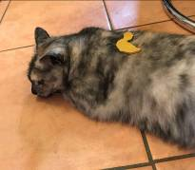

Hmm, definitely not keen. I think we’ll stick to dog testers. So the rest were wrapped up and given as gifts to some good dog friends:
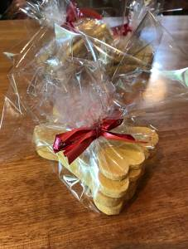

So what did the lucky recipients think?

Tora the Border Collie-
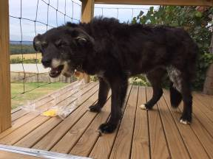
I feel like this facial expression is conveying that they are a bit on the dry side…

How about Pudding the Staffie?

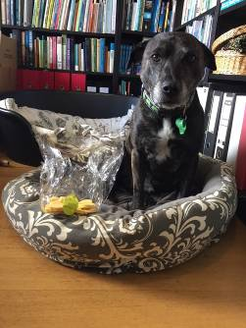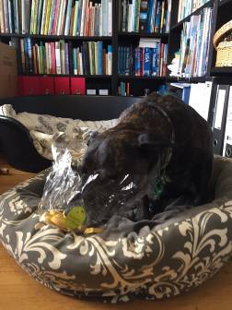

He clearly thinks they are just right!

So the results are in and this is definitely a fun and yummy recipe for you to try at home. Feel free to run any recipes that you’d like to try past one of our vets or nurses to ensure they are safe for your pet. We’d love to see the finished product and hear how they performed in the all important taste testing.

Happy baking.

Emma

